Pressemitteilung
Aktuell: Wirtschaftsmeldung 2020-01-21

After six record years in a row: AMF 2019 slowing growth but with confidence

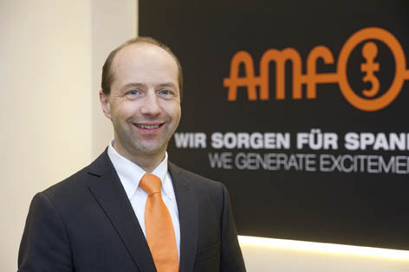
Record run at AMF stopped
Kontakt für die Presse:
ANDREAS MAIER
GmbH & Co. KG
Marcel Häge
Waiblinger Straße 116
D-70734 Fellbach
Tel. +49 (0)711 – 57 66 - 264
haege@amf.de
www.amf.de

(Fellbach) After six record years in a row, the annual turnover of Andreas Maier GmbH & Co.KG (AMF) in 2019 declined slightly again for the first time. With 47.3 million euros, the market leader for clamping, screwing and closing recorded a decline of almost 5.5 percent. The traditional company was still on course until summer, followed by a real slump and reluctance to buy in September, which affected the entire industry. However, because the innovative products of the future in the growth areas of automation, process optimisation and additive manufacturing still showed a clear increase, the management is optimistic about the future. Further investments in in-house production, digitisation and training of employees should reverse the trend in 2020.
"After six sales records in succession, it is not surprising that it could not go on forever under the difficult global political conditions with trade conflicts, Brexit and general uncertainty," emphasizes Johannes Maier, managing partner of Andreas Maier GmbH & Co. KG in Fellbach. With 47.3 million euros in annual sales, the market leader for clamping, screwing and closing recorded a decline of almost 5.5 percent in 2019 compared to the previous year. Maier attributes the main reasons for this to a general reluctance in the placement of orders in the fourth quarter due to the uncertainties in all markets. "The companies are planning very carefully and for increasingly shorter periods, but that can just as quickly tip in the other direction," believes Maier. This is also reflected by the many contacts and discussions that were held at the EMO trade fair in September. "That was far more than we have ever registered," said Maier. For this reason, he wants to remain flexible with his company and be able to react quickly.
Confidence for 2020 thanks to future-proof products
Those responsible see reason for optimism in the continued strong growth of innovative products for automated production and additive manufacturing. With the zero-point clamping system "Zero-Point", the AMF radio sensor system and the gripper, which was newly introduced in 2019, AMF has competitive solutions for automation on the machine table that are establishing themselves worldwide. In 2019, another innovative product with a new loading system was added. This means that AMF can also automate the path of the workpieces to the machine and support low-manpower production. In times of a shortage of skilled workers, this is an important aspect that underlines the traditional company's flair for future-proof solutions.
AMF continues to see growth opportunities in the field of ​​automation in Germany and Europe. From the international markets, Asia with India, the USA and Eastern Europe are the focus of the sales activities. Investments are planned again in 2020 in our own production. This means that machines will be renewed, digitalisation will be further expanded and employee qualifications enhanced. AMF also wants to maintain the training quota of ten percent of its employees. "In this way, we want to return to the path of growth with optimism, courage and strategy," concludes Maier.
503 Wörter, 3.169 Zeichen
Bei Abdruck bitte zwei Belegexemplare an SUXES, Endersbacher Straße 69, 70374 Stuttgart
Text und Bilder auch unter www.pressearbeit.org

((AMF company information))
Market leader in machine table clamping
Andreas Maier Fellbach (AMF), originally founded in 1890, today is a one-stop supplier in clamping technology and is one of the world market leaders. With a global market presence, the company and its employees always have an open ear for the problems of their customers. By listening to these needs, and through its strong problem-solving ability, professional consultancy, intelligent engineering and high manufacturing quality, AMF repeatedly develops project fabrications and customised solutions for customers as well as standard solutions that succeed in the market again. With more than 6,000 products and numerous patents, it ranks among the top innovators in the industry. Speed, flexibility and 230 well-qualified employees guarantee success at Andreas Maier GmbH & Co. KG. In 2019, AMF earned revenue of more than 47 million euros.
Bilderverzeichnis AMF, Fellbach.
Mit 2 Klicks zu Text und Bild unter www.pressearbeit.org.
Bild Nr. 92-01 AM_JohannesMaier.jpg
Johannes Maier, Managing Partner of AMF, sees opportunities for growth in 2020 as well.

